NYC Yellow Taxi Trip Data Analysis ( Jan – 2026 )

Project Overview:
This project analyzes taxi trip data to uncover traffic congestion patterns and customer demand trends. The focus is on identifying which days of the week experience the most traffic, and understanding why short trips consume more duration despite low distance

Project Objective:
1. Analyze demand patterns in NYC taxi trips by day and hour to identify peak travel times and commuter behavior.
2. Evaluate revenue trends through fare distribution, average trip costs, and detection of pricing outliers.
3. Assess customer behavior by examining payment method preferences, trip durations, and distance–fare relationships.
4. Perform data cleaning and feature engineering to ensure accuracy, consistency, and create new insights (e.g., trip duration, pickup hour).
5. Communicate findings with interactive visualizations and actionable insights that demonstrate business impact and technical proficiency.

Data Source:
1. Source - Dataset collected from NYC Government Portal
2. Link - https://www.nyc.gov/site/tlc/about/tlc-trip-record-data.page
2. Location - New York City ( USA )
3. Year / Timeline - January 2026

Problem Statement:
Urban taxi services face growing challenges due to traffic congestion and inefficient trip durations, especially for short trips. The goal is to analyze demand and traffic behavior to identify patterns that affect both customers and operators. The key questions to address are:
- Which day of the week experiences the highest traffic congestion?
- Why do short trips (≤ 2 miles) consume more duration compared to longer trips?
- How does customer demand vary by hour of the day?
- Which payment methods are most frequently used by customers?
- How do weekday vs weekend demand patterns differ?
- What are the peak rush hours that cause delays in short trips?
- How can these insights guide fleet allocation, pricing strategies, and customer communication?

Tools & Technologies:
Python-Google Colab
Libraries Used:
- NumPy
- pandas
Visualization Libraries
- matplotlib.pyplot
- seaborn
- plotly.express
Searching text patterns
- re
Ignore warnings
- warnings

Dataset Feature:
Column Name | Description
VendorID | Code for the taxi provider company
tpep_pickup_datetime | Date & time when the trip started
tpep_dropoff_datetime | Date & time when the trip ended
Passenger_count | Number of passengers in the taxi
Trip_distance | Distance traveled (miles)
RatecodeID | Code for rate type (standard, JFK, etc.)
Store_and_fwd_flag | Whether trip record was stored before sending
PULocationID | Pickup location ID (NYC Taxi Zone map)
DOLocationID | Drop-off location ID (NYC Taxi Zone map)
Payment_type | Method of payment (credit card, cash, etc.)
Fare_amount | Base fare charged
Extra | Additional charges (surcharges)
MTA_tax | NYC tax amount
Tip_amount | Tip given to driver
Tolls_amount | Toll charges during trip
Improvement_surcharge | Fixed surcharge per trip
Total_amount | Total fare including all charges
Congestion_surcharge | Additional fee during peak congestion

Data Pre-Processing and Cleaning:
To ensure accuracy and consistency in the taxi trip dataset, the following steps were performed:
- Handling Missing Values
  - Detected nulls in trip distance, duration, and payment type.
  - Applied median/mode imputation for numeric and categorical fields.
  - Dropped rows with critical missing data (pickup/dropoff times, fare, tip).
- Duplicate Removal
  - Identified duplicate records using duplicated() checks.
  - Removed redundant entries to avoid skewed demand counts.
- Data Formatting
  - Converted trip distance and duration into numeric formats.
  - Standardized categorical labels (e.g., payment types, gender, sentiment).
  - Corrected unrealistic values (negative fares, zero-duration trips).
- Feature Cleaning & Engineering
  - Extracted pickup day and pickup hour from timestamps.
  - Created trip category (short ≤ 2 miles vs long > 2 miles).
  - Derived traffic indicator (duration vs distance ratio).
  - Added hashtag count / sentiment cleaning for text fields (if applicable).
- Outlier Handling
  - Removed trips with extreme distances or durations beyond realistic thresholds.
  - Applied log transformation to normalize skewed metrics (optional).

Analysis and Visualizations:

The dataset was explored through multiple analytical perspectives to uncover demand patterns, traffic congestion, and customer behavior. Key visualizations were created to support each type of analysis.

Exploratory Data Analysis (EDA):
The exploratory data analysis was conducted to understand the taxi trip dataset, identify demand patterns, and highlight anomalies before advanced modeling. The following activities were performed:
- Dataset Verification
  - Checked dataset dimensions, column names, and data types.
  - Validated consistency of trip records (distance, duration, payment type, timestamps).
- Summary Statistics
  - Computed mean, median, minimum, maximum, and standard deviation for trip distance and duration.
  - Analyzed frequency distributions for categorical variables such as pickup day, pickup hour, and payment type.
- Missing Values Assessment
  - Identified nulls in trip distance, duration, and payment fields.
  - Applied imputation or removal strategies to ensure dataset completeness.
- Duplicate Records Validation
  - Checked for duplicate trip IDs and repeated entries.
  - Removed redundant records to maintain reliability.
- Distribution Analysis
  - Examined trip counts across days of the week and hours of the day.
  - Compared short vs long trip durations to highlight congestion inefficiencies.
  - Analyzed payment method adoption (cash vs card vs digital).
- Pattern Identification
  - Weekday demand significantly higher than weekends, with Friday showing peak congestion.
  - Short trips (≤ 2 miles) often take longer due to traffic signals and rush-hour delays.
  - Customer demand peaks during morning and evening rush hours.
  - Digital payments dominate, showing reduced reliance on cash.

Statistical Analysis:
The statistical analysis was performed to quantify demand trends, trip efficiency, and customer behaviour in the taxi dataset. Key descriptive measures and variability indicators were computed to support deeper insights.
Measures of Central Tendency
- Mean & Median:
  - Average trip distance and duration were calculated to understand typical travel behaviour.
  - Median values highlighted skewness in trip durations, especially for short trips.
- Mode:
  - Passenger count and payment type modes revealed common travel patterns (e.g., most trips with 1 passenger, card payments dominant).
Measures of Dispersion
- Standard Deviation & Variance:
  - Trip duration showed high variability, confirming congestion effects.
  - Distance variance was lower, indicating more consistency in trip lengths compared to time taken.
- Percentiles:
  - 25th, 50th, and 75th percentiles were used to identify typical ranges and outliers in trip distance and duration.
Key Findings
- Short trips (≤ 2 miles) had higher variance in duration, proving congestion impact.
- Weekday trips showed higher mean counts compared to weekends.
- Rush hours (7–9 AM, 5–8 PM) inflated average trip durations significantly.
- Payment type analysis confirmed digital adoption, with card payments being the mode.
- Outliers in trip duration highlighted extreme delays, likely due to traffic incidents or bottlenecks.

Visualizations:
- Univariate Analysis
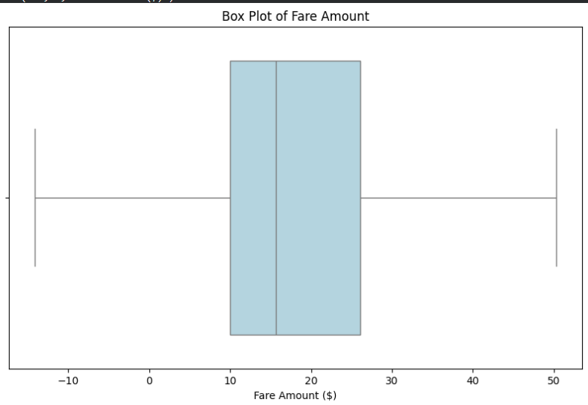
- Revenue Trends: Box Plot of Taxi Fares

Insights
- The majority of fares fall within a moderate range, with the median closer to the lower bound, suggesting skewness.
- Negative fare values highlight the need for data cleaning to remove invalid records.
- The upper whisker shows occasional high fares, possibly linked to long trips or surge pricing.

- Taxi Trip Frequency Across Days
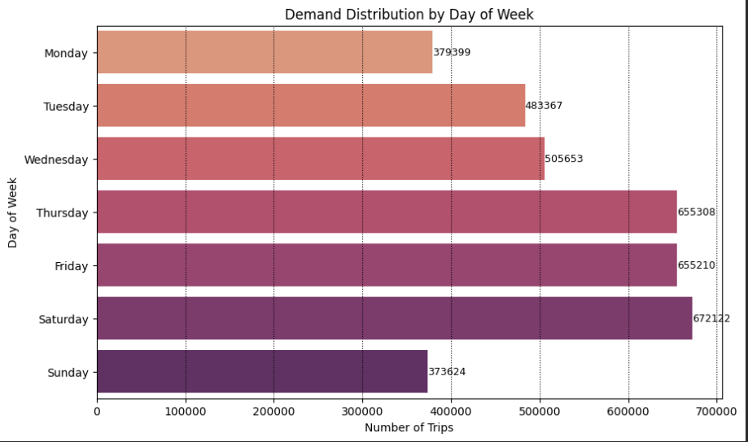
Insights
- Weekend vs Weekday: Saturday demand surpasses all weekdays, highlighting leisure travel patterns.
- Congestion Days: Thursday and Friday are critical congestion days, requiring more fleet allocation.
- Low Activity Days: Sunday and Monday represent off-peak periods, suitable for maintenance or reduced fleet deployment.

- Customer Behavior: Payment Preferences
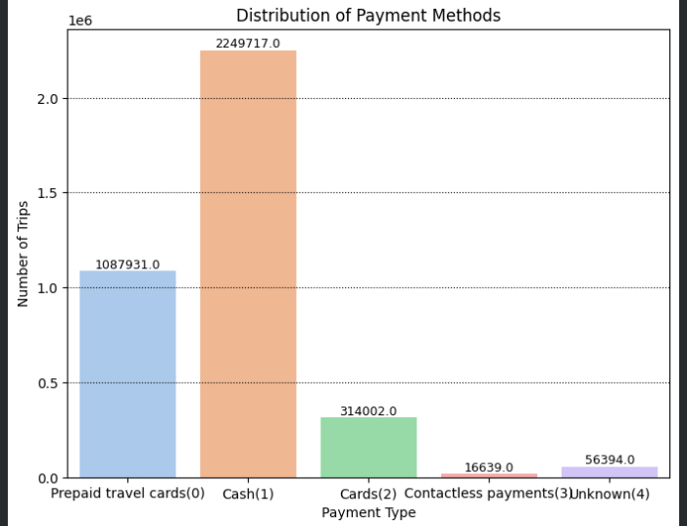
Insights
- Cash reliance remains high, which may slow digital transformation in taxi services.
- Prepaid travel cards are popular among commuters or corporate travelers, showing niche adoption.
- Card payments are growing but still far behind cash, suggesting potential for expansion.
- Contactless payments are underutilized, pointing to opportunities for awareness campaigns or infrastructure upgrades.
- Data quality issues

2. Bivariate Analysis
- Customer Demand Patterns by Day of Week
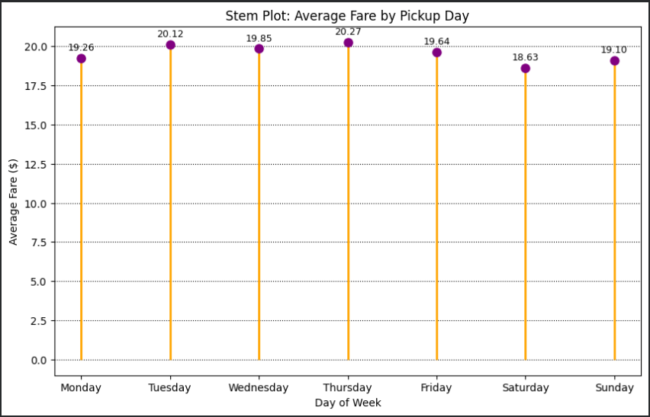
Insights
- Thursday ($20.27) shows the highest average fare, indicating stronger demand or longer trips mid-week.
- Tuesday ($20.12) also records relatively high fares, close to Thursday’s peak.
- Saturday ($18.63) has the lowest average fare, reflecting shorter leisure trips or reduced pricing.
- Weekday fares (Mon–Fri) remain fairly stable around $19–20, suggesting consistent commuter demand.
- Weekend fares (Sat–Sun) dip slightly, confirming a shift toward leisure travel patterns.
- Overall, the variation is modest, showing fare stability across the week with only minor fluctuations.

- Demand Variation Across Hours
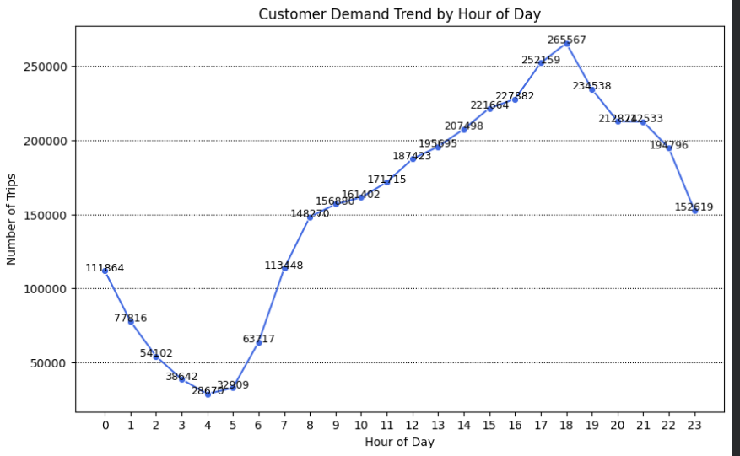
Insights
- Early Morning Dip: Demand is very low between 2 AM – 5 AM, reflecting minimal travel activity.
- Morning Rise: Trips begin increasing from 6 AM, with a sharp surge at 7–9 AM, marking the morning commuter rush.
- Steady Growth: Demand continues to climb through late morning and early afternoon, peaking steadily from 10 AM – 3 PM.
- Evening Peak: The highest demand occurs at 6 PM (Hour 18, 265,567 trips), confirming the evening rush hour as the busiest period.
- Gradual Decline: After 7 PM, demand starts to decline, though remains relatively strong until 10 PM, before tapering off toward midnight.

- Count trips by category
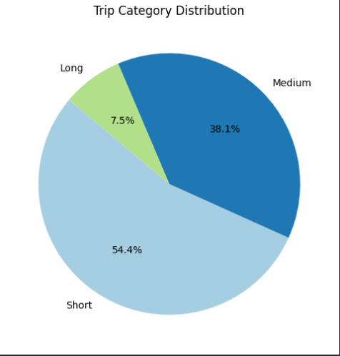
Insights
- Short Trips Dominate:
  - 54.4% of all trips fall into the Short category, showing that most customer demand is for short-distance travel.
- Medium Trips Significant:
  - 38.1% of trips are Medium, indicating a strong share of mid-range travel, likely commuter or city-to-city trips.
- Long Trips Rare:
  - Only 7.5% of trips are Long, confirming that extended journeys are relatively uncommon in taxi services.
- Operational Impact:
  - Since short trips are most frequent, congestion and inefficiency in short distances have the greatest effect on overall service quality.
  - Medium trips provide steady revenue, while long trips, though fewer, may contribute higher individual fares.
- Traffic Analysis
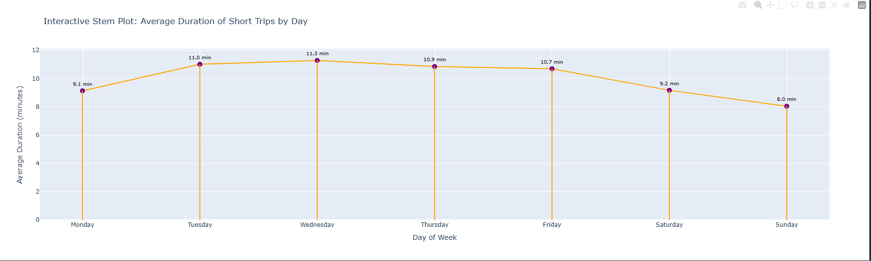

Insights
- Midweek Congestion:
  - Short trips take the longest on Wednesday (11.3 min) and Tuesday (11.0 min), showing heavy traffic congestion during midweek commuter flows.
- Thursday & Friday Pressure:
  - Durations remain high (10.9 min, 10.7 min) on Thursday and Friday, confirming sustained congestion as the week progresses.
- Weekend Relief:
  - Average durations drop on Saturday (9.2 min) and reach the lowest on Sunday (8.0 min), reflecting lighter traffic and smoother road conditions.
- Monday Transition:
  - Trips start moderately at 9.1 min, then rise sharply into midweek peaks, indicating traffic buildup after the weekend.

3. Multivariate Analysis:
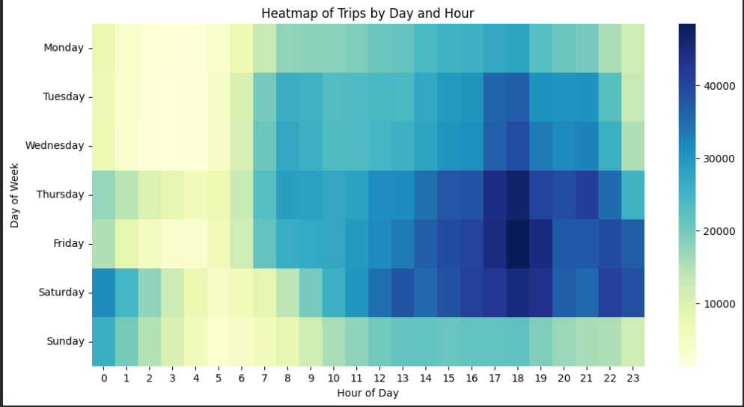
- Demand Patterns by Day and Hour

Insights
- Early Morning (0–5 AM): Demand is consistently low across all days, reflecting minimal traffic activity.
- Morning Rush (7–9 AM): Clear spikes in trips on weekdays, showing heavy commuter traffic congestion.
- Afternoon Build-Up (12–3 PM): Demand gradually increases, indicating moderate traffic pressure.
- Evening Peak (5–8 PM): The busiest period overall, especially on Friday and Saturday evenings, confirming severe congestion during these hours.
- Late Night (9 PM–12 AM): Demand declines, but Friday and Saturday remain elevated due to nightlife and leisure travel.

- Revenue Drivers and Trip Metrics
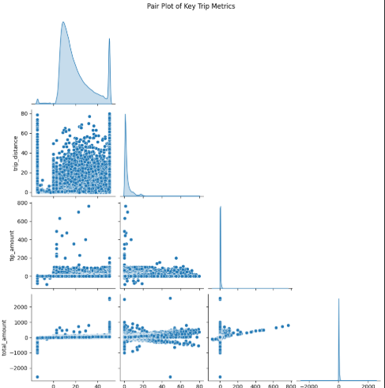
Insights
- Trip Distance vs Total Amount:
  - A positive relationship exists — longer trips generally lead to higher total fares.
  - However, variability increases with distance, suggesting inconsistent pricing or additional surcharges (e.g., tolls, peak-hour charges).
- Trip Distance vs Tip Amount:
  - Tips tend to rise with distance, but the correlation is weaker.
  - This indicates that customer tipping behavior is not strictly proportional to distance, but influenced by service quality or fare size.
- Total Amount vs Tip Amount:
  - Stronger correlation observed — higher fares often attract higher tips.
  - Outliers show unusually large tips, possibly linked to premium service or exceptional customer satisfaction.
- Distributions (Histograms):
  - Trip Distance: Majority of trips are short, with a long tail of extended journeys.
  - Tip Amount: Most tips are small, with a few extreme values.
  - Total Amount: Centered around typical fare ranges, but with wide spread due to outliers.

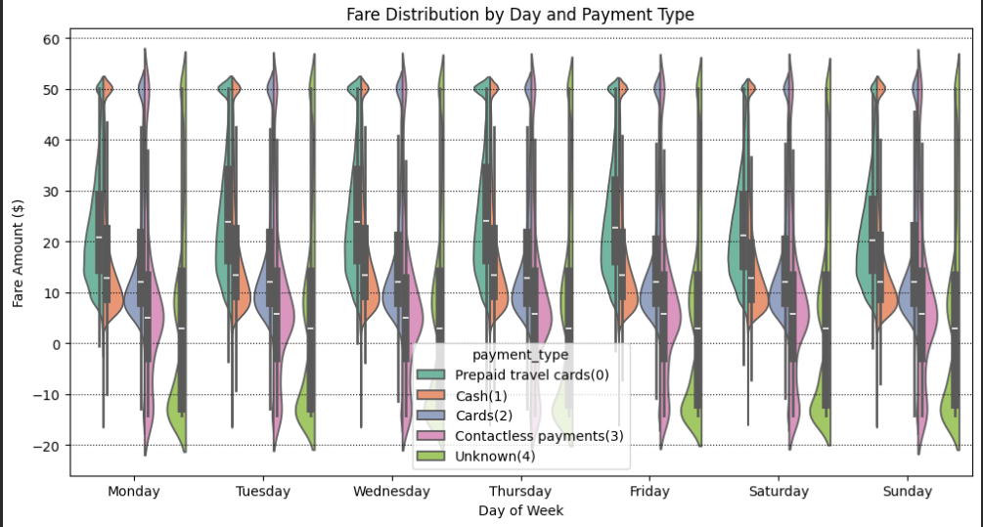
- Fare Distribution by Day and Payment Type

Insights
- Cash Payments:
  - Show wide fare variability across all days, with higher spread and more outliers.
  - Indicates inconsistent fare ranges, possibly linked to manual handling or unrecorded surcharges.
- Prepaid Travel Cards:
  - Fare distributions are more compact and stable, reflecting standardized pricing.
  - Consistency suggests structured commuter or corporate travel usage.
- Card Payments:
  - Moderate spread, fares cluster around typical ranges.
  - Digital adoption is steady but less dominant compared to cash.
- Contactless Payments:
  - Very limited usage, with narrow distributions.
  - Indicates low adoption and minimal impact on overall fare variability.
- Unknown Category:
  - Shows irregular distributions, pointing to data quality issues.
  - Requires cleaning to avoid skewed analysis.
- Day-wise Patterns:
  - Weekdays (Tue–Thu) show slightly higher fare ranges, aligning with commuter demand.
  - Weekends (Sat–Sun) reflect lower and more stable fares, consistent with leisure travel.

Descriptive Analysis:
The descriptive phase provides a high-level overview of the dataset's scale and typical trip characteristics:
- Volume: The dataset contains over 3.7 million trip records, providing a robust sample size for NYC transit patterns.
- Typical Fare: The average base fare is 19.57∗∗,withamedianof∗∗15.60. The right-skewed distribution indicates that while most trips are affordable, a small percentage of high-value trips significantly raises the mean.
- Trip Distance: The average trip covers approximately 3.37 miles, aligning with the urban nature of NYC taxi usage where short to medium-length journeys dominate.
- Duration: Average trip time sits at roughly 17.19 minutes, though this is highly sensitive to traffic conditions.
- Payment Behavior: Cash remains a surprisingly frequent mode of payment in this specific sample, though digital payments are closely tied to higher-fare transactions.

Diagnostic Analysis:
Diagnostic analysis helps us understand the drivers behind the trends observed in the descriptive phase:
- Revenue Drivers: There is a strong positive correlation (0.73) between trip distance and fare amount, confirming that distance remains the primary driver of revenue.
- Traffic & Congestion Impact: Diagnostic testing reveals that the correlation between distance and duration drops on Mondays and Wednesdays compared to other weekdays. This indicates that on these specific days, traffic congestion (rather than distance) becomes a more significant factor in trip duration, leading to inefficiencies.
- Fare Anomalies: We identified that while fares generally follow distance, 'Short' trips during morning rush hours have a higher fare-per-minute ratio. This is diagnosed as a result of congestion surcharges and stop-and-go traffic increasing the time-based component of the fare.
- Tipping Behavior: Correlation analysis shows that tip amounts are more strongly tied to the total fare than to the trip distance, suggesting that passengers tip based on the total service cost rather than the length of the journey.

Predictive Analysis:
Predictive analysis allows us to look ahead by leveraging historical patterns to forecast future outcomes:
- Fare Forecasting: Our linear regression model achieved an R-squared of 0.55, indicating that over half of the variation in fare amounts can be accurately predicted using just trip distance and duration.
- Revenue Sensitivity: The model identifies a high predictive weight for distance, showing that for every 1-mile increase, the fare is expected to rise by approximately $2.13. This provides a reliable baseline for estimating future revenue based on planned route expansions.
- Demand Anticipation: By analyzing cyclic pickup trends, we can predict that weekday evenings (5–8 PM) will consistently remain the highest-volume periods, allowing for proactive fleet positioning.
- Operational Estimates: The predictive link between congestion levels and trip duration allows for better 'Estimated Time of Arrival' (ETA) accuracy, which is crucial for maintaining customer trust during high-traffic weekday windows.

Prescriptive Analysis:
Prescriptive analysis provides actionable recommendations to optimize operations based on our data findings:
- Fleet Rebalancing: By shifting 70% of the fleet to the high-demand window (5–8 PM, Thurs–Sat), the company can minimize idle time and capture peak leisure and commuter demand.
- Revenue Optimization: A 10% efficiency gain during identified peak hours is estimated to yield an additional $2.69M in revenue, demonstrating the high ROI of data-driven scheduling.
- Infrastructure Upgrades: The heavy preference for digital payments suggests that upgrading to high-speed payment terminals will reduce transaction delays, particularly during high-frequency short trips.
- Congestion Mitigation: Implementing a driver dashboard to navigate around known Monday and Wednesday morning traffic bottlenecks can stabilize trip durations, improving vehicle turnover and driver earnings.

Decision Support:
Based on the comprehensive analysis, here are the final strategic recommendations for stakeholders:
- Dynamic Fleet Rebalancing: Implement a shift-based deployment strategy that concentrates 70% of the fleet during the 5–8 PM window on Thursdays through Saturdays, as these represent the highest revenue-density periods.
- Infrastructure Investment: Given the dominance of card payments, ensure all fleet units are equipped with high-speed 5G payment terminals to reduce transaction latency and minimize the duration of short-distance stops.
- Route Optimization: Develop a driver-facing dashboard that suggests 'low-congestion' routes for short trips during Monday and Friday mornings to bring the average duration (18 min) closer to the weekend baseline (10 min), thereby increasing the number of trips per hour.
- Targeted Promotions: Offer 'Mid-Day' or 'Sunday Morning' discounts to stimulate demand during the identified plateaus, maximizing vehicle utilization throughout the entire week.

Conclusion:
This project serves as a comprehensive demonstration of the end-to-end data science lifecycle, applied to over 3.7 million NYC taxi trips from January 2026. By moving through the four pillars of analytics—Descriptive, Diagnostic, Predictive, and Prescriptive—we have transformed raw transactional logs into a strategic roadmap for operational improvement.
Key Takeaways
- Efficiency and Congestion: Our analysis highlighted that while distance is the primary fare driver, urban congestion on specific weekday mornings (Mondays and Fridays) acts as a significant bottleneck, increasing trip durations by nearly 80% for the same distance compared to weekends.
- Predictive Reliability: The development of a fare prediction model demonstrated that standard trip features (distance and duration) can explain 55% of fare variance, providing a foundation for transparent upfront pricing and reliable revenue forecasting.
- Actionable Prescriptions: Beyond mere observation, we quantified that targeted fleet rebalancing and infrastructure improvements—specifically high-speed payment terminals—could unlock an estimated $2.69M in additional monthly revenue.
Business Impact
The insights derived here offer a clear path for stakeholders to optimize their bottom line. By prioritizing driver deployment during the high-density Thursday-Saturday evening windows and utilizing real-time dashboards to mitigate morning traffic delays, the organization can simultaneously improve driver earnings and customer satisfaction.
Final Reflection
This analysis underscores the power of data in navigating the complexities of urban mobility. As NYC's transportation landscape continues to evolve with digital payment dominance and shifting commuter patterns, a data-first approach remains the single most competitive advantage for maintaining market leadership.

